WonBin Seo
Dr. Shannon Nicley,
ECE 813 Advanced VLSI Design
26 March 2025
Exam2
Problem 1 – 4-bit Adder Schematic – [MCGA4_Schematic]
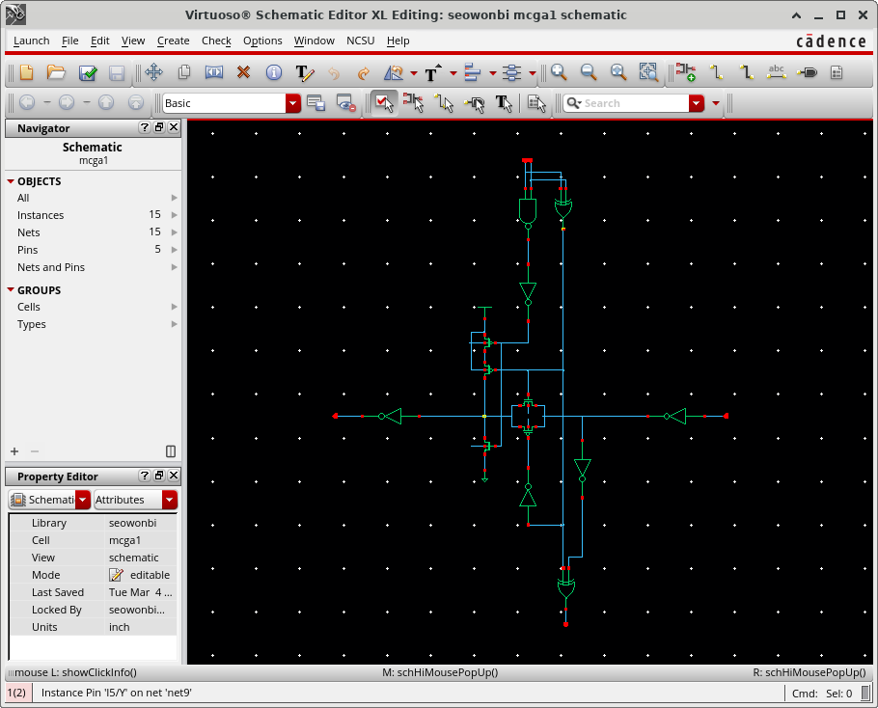
Figure 1. MCGA1_Schematic
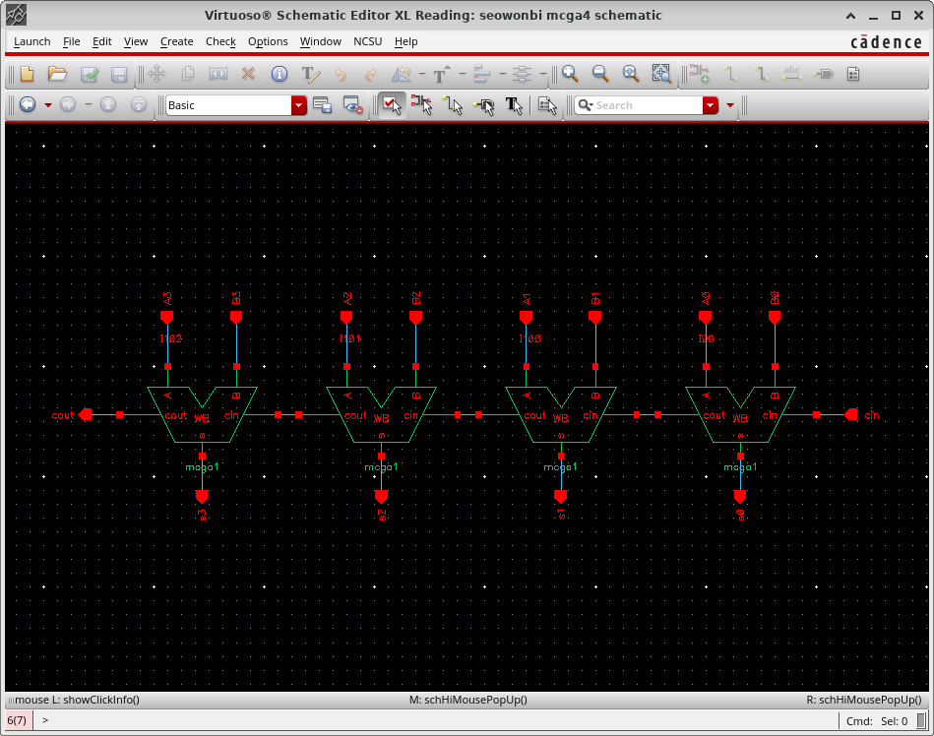
Figure 2. MCGA4_Schematic

Problem 2 – 4-bit Adder Symbol [MCGA4_Symbol]
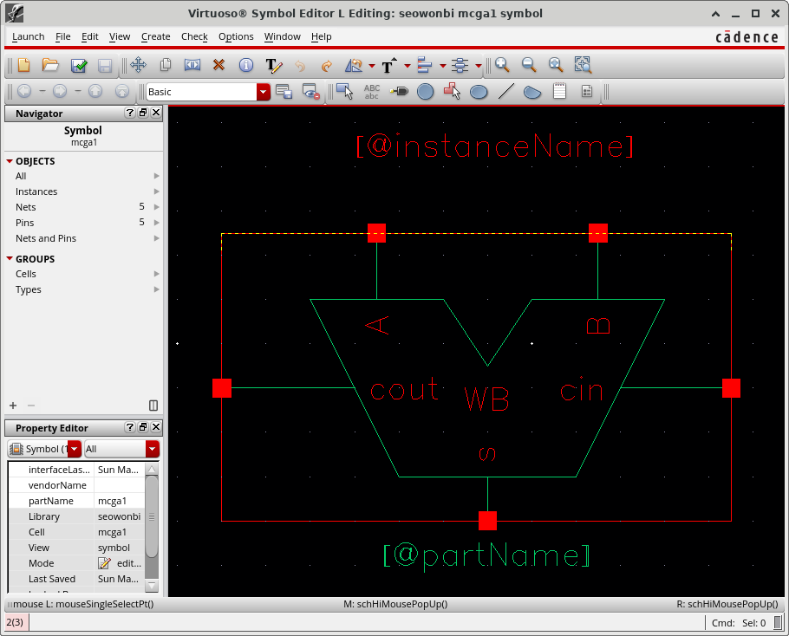
Figure 3. MCGA1_Symbol
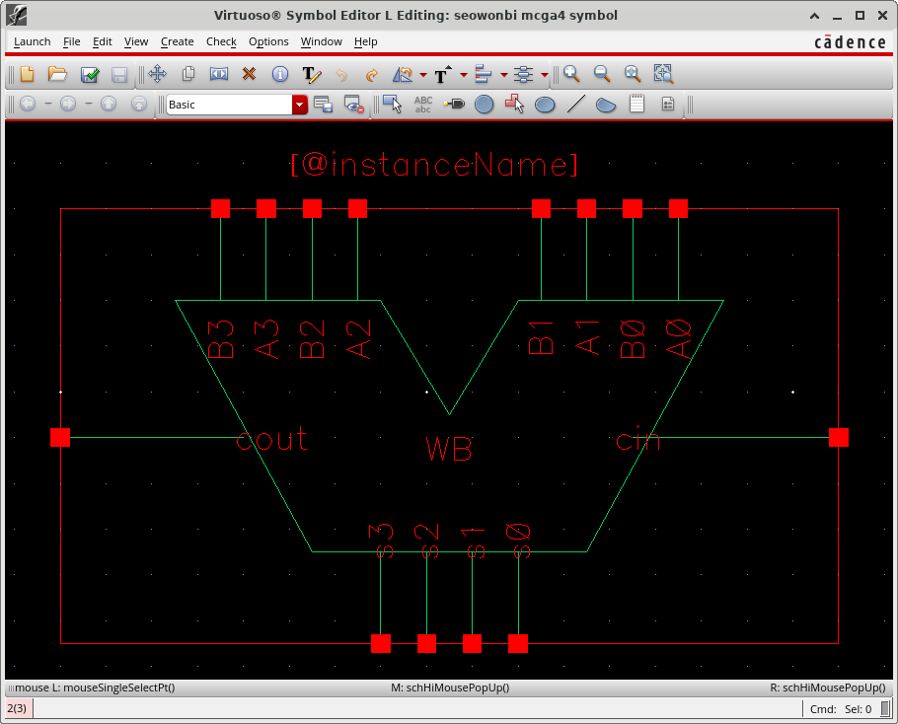
Figure 4. MCGA4_Symbol

Problem 3 – 4-bit Adder Layout - [MCGA4_Layout]
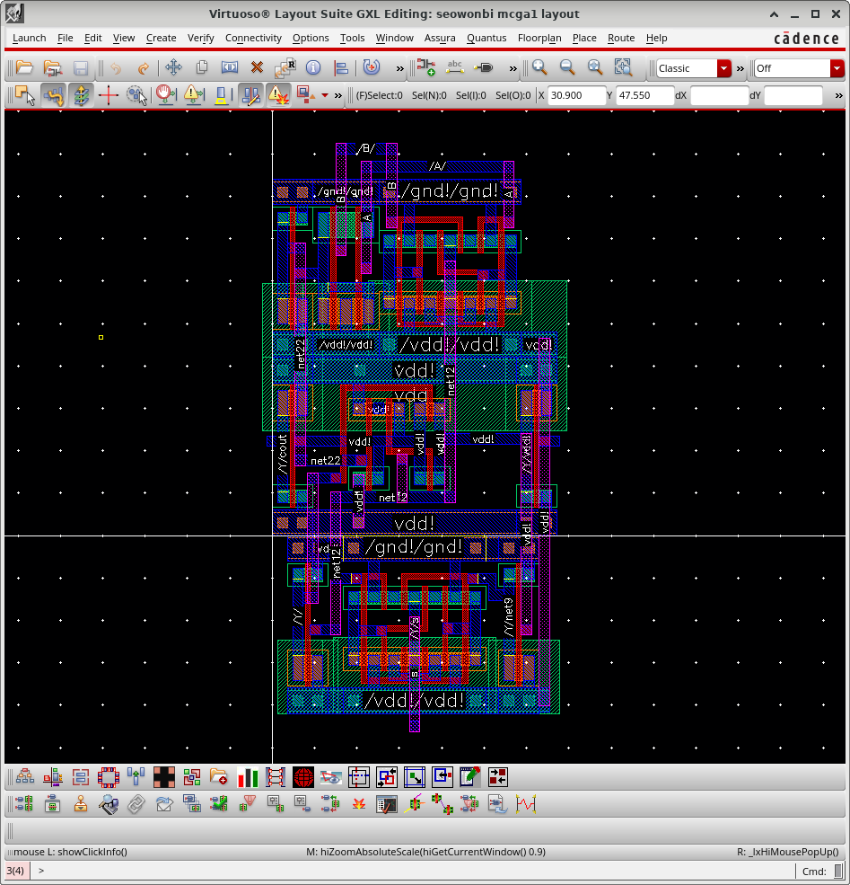
Figure 5. MCGA1_Layout
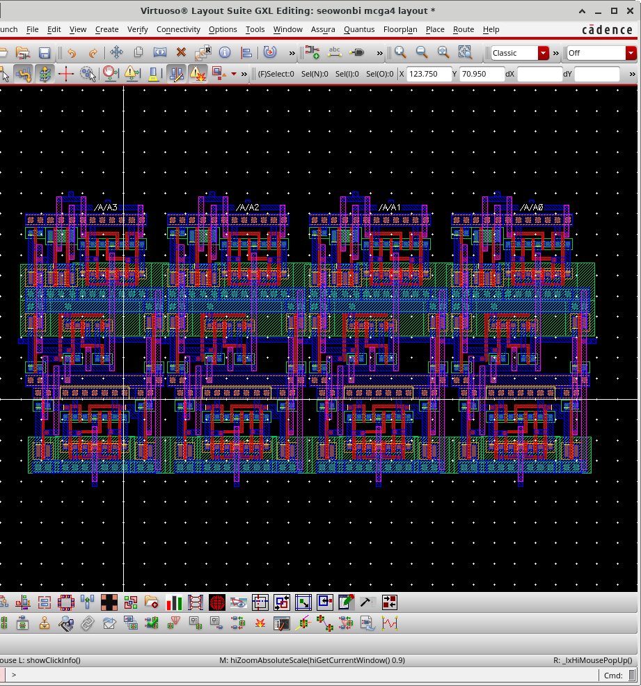
Figure 6. MCGA4_Layout

Problem 4 – Carry Lookahead Schematic – [CLA_Schematic]
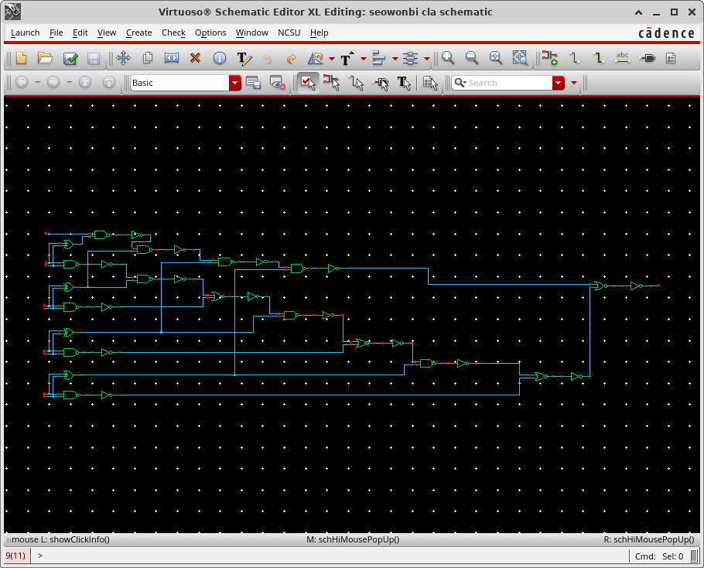
Figure 7. Carry Lookahead Schematic

Problem 5 – Carry Lookahead Symbol [CLA_Symbol]
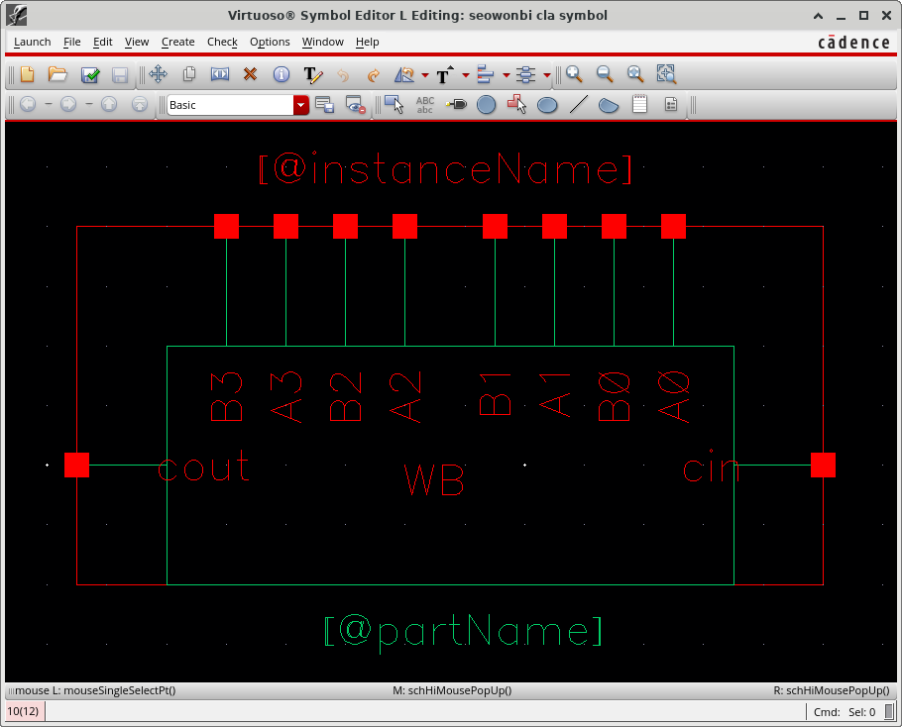
Figure 8. Carry Lookahead Symbol

Problem 6 – Carry Lookahead Layout - [CLA_Layout]
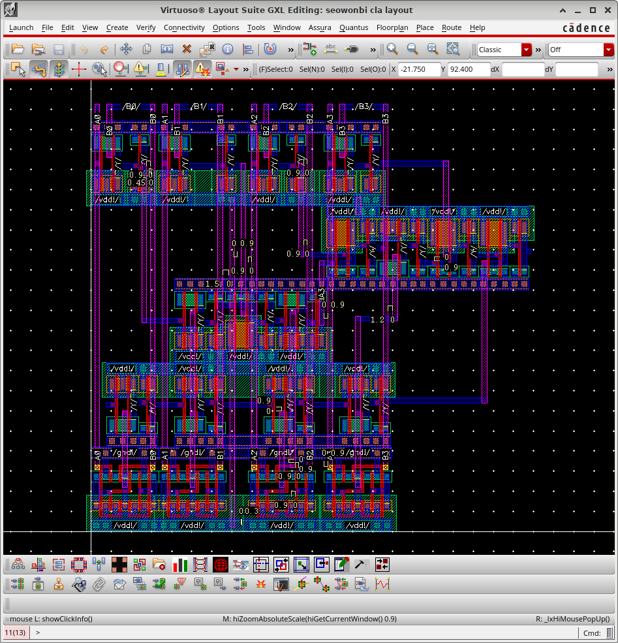
Figure 9. Carry Lookahead Layout

Problem 7 – 8-bit Adder Schematic – [MCGACLA8_Schematic]
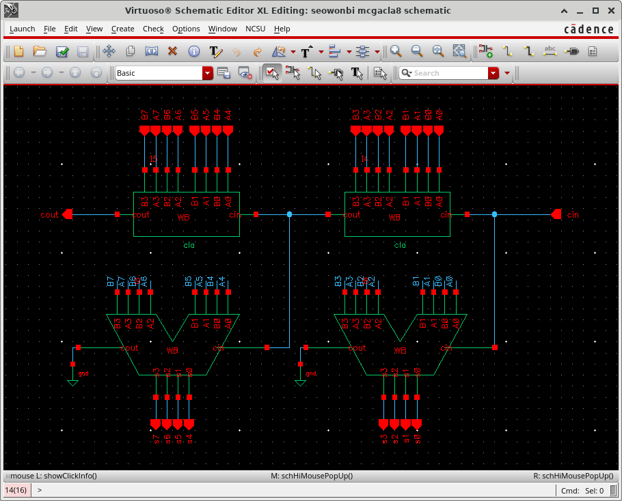
Figure 10. 8-bit Manchester Carry Generation Carry Lookahead Adder Schematic

Problem 8 – 8-bit Adder Symbol – [MCGACLA8_Symbol]
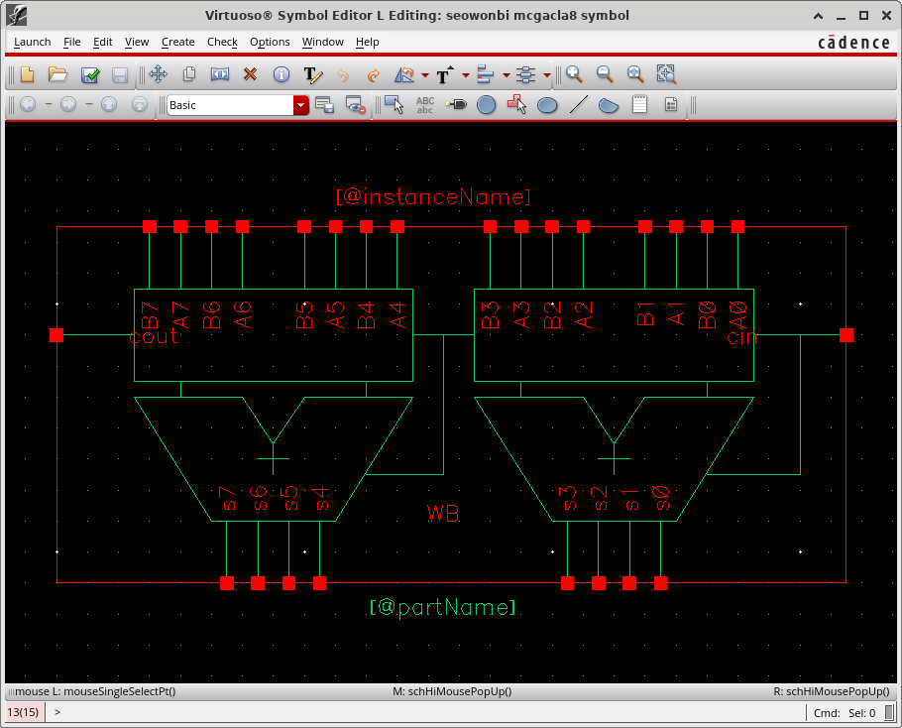
Figure 11. 8-bit Adder Symbol

Problem 9 – 8-bit Adder Layout - [MCGACLA8_Layout]
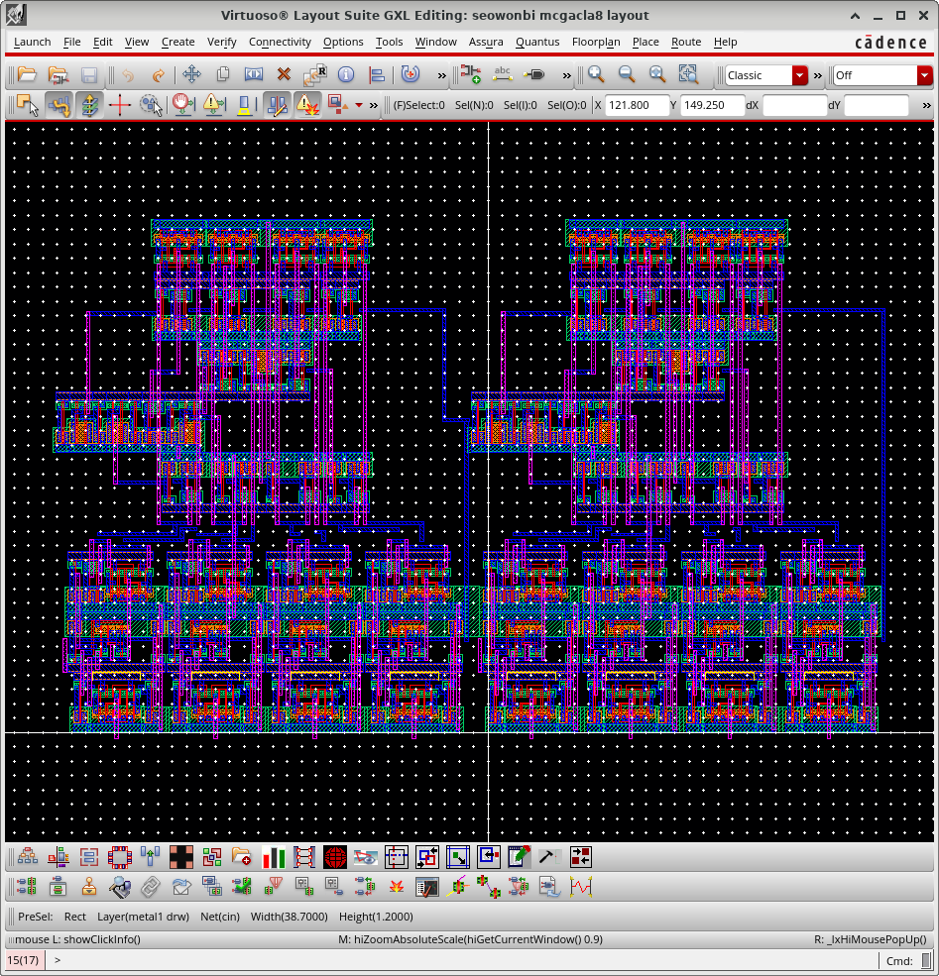
Figure 12. 8-bit Adder Layout

Problem 10 – 8-bit Adder LVS
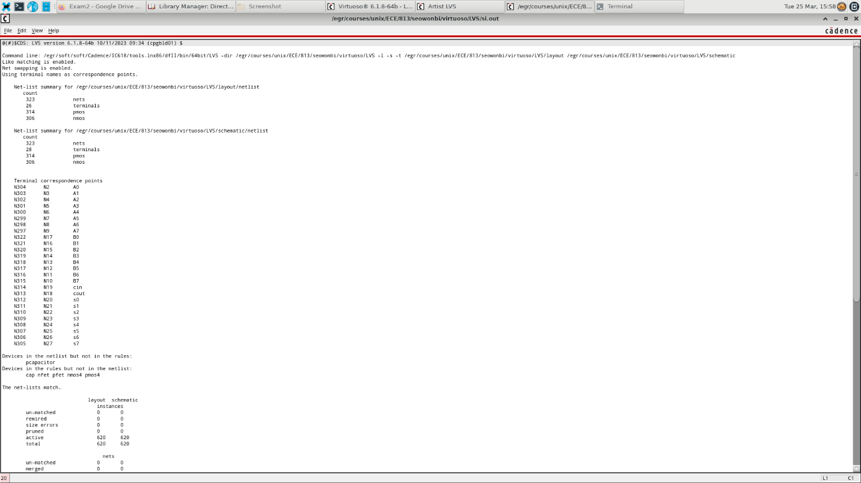
Figure 13. 8-bit Adder LVS
Problem 11 – 8-bit Adder Simulation
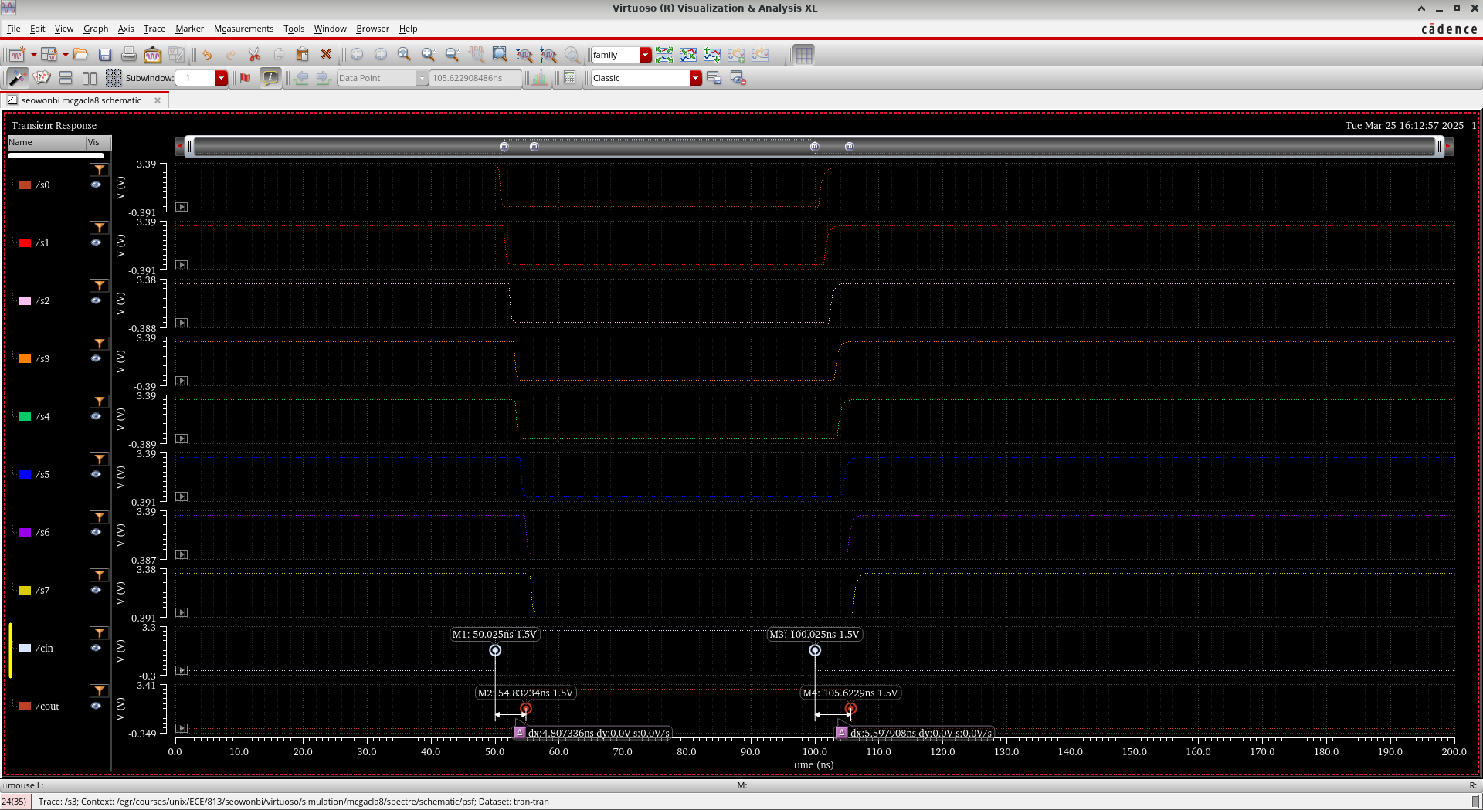
Figure 14. 8-bit Adder Simulation

Rise time delay: 4.807336ns, Falling time delay: 5.597908ns
A | B | Cin | s0 | s1 | s2 | s3 | s4 | s5 | s6 | s7 | cout
1 | 0 | 0 | 1 | 1 | 1 | 1 | 1 | 1 | 1 | 1 | 0
1 | 0 | 1 | 0 | 0 | 0 | 0 | 0 | 0 | 0 | 0 | 1
1 | 0 | 0 | 1 | 1 | 1 | 1 | 1 | 1 | 1 | 1 | 0
1 | 0 | 0 | 1 | 1 | 1 | 1 | 1 | 1 | 1 | 1 | 0
Figure 15. Truth Table of the 8-bit Adder

